Ahmad Rawashdeh, Ph.D.
Email: ahmedyr2003@gmail.com, arawashdeh@ucmo.edu
Linkedin: https://www.linkedin.com/pub/ahmad-rawashdeh/38/536/275

Degrees:
- PhD (2015): Computer Science at the University of Cincinnati. GPA: 3.8/4
- Master (2009): Computer Science at Jordan University of Science and Technology, ranked second. GPA: 91 (ranked 2nd)
- Bachelor (2006): Computer Science and Information System at Jordan University of Science and Technology, ranked third. GPA: 85 (ranked 3rd)

Papers:
- Rawashdeh, A., Ralescu, A., (April 26, 2015). “Similarity Measure for Social Networks – A Brief Survey”. Proceedings of the 26th Modern AI and Cognitive Science Conference (MAICS).

- Rawashdeh, R. Dwairi, (2007).“A User Centered Matchmaking and Ranking System”. The 1st International Conference on Digital Communications and Computer Applications, Irbid, Jordan.

- Rawashdeh, A. Ralescu, (October 10-12, 2013). “Evaluating the Similarity between Unstructured Text Data”. Third International Conference Modelling and Development of Intelligent Systems Sibiu, Romania.

- Rawashdeh, M. Rawashdeh, I. Diaz, A. Ralescu, (July 15-19 2014.). “Measures of Semantic Similarity of Nodes in a Social Network”. 15th International Conference on Information Processing and Management of Uncertainty in Knowledge-Based Systems. Montpellier, France..

- Master Thesis “Automatic Concept Extraction from Arabic Text”

- Najadat, H., Rawashdeh, A., (2015) “Concept Extraction from Arabic Text Based On Semantic Analysis”. Proceedings of the The International Technology Management Conference, Antalya, Turkey.

Work Experiences:
- Assistant Professor at the University of Central Missouri (August 2015 – present)
- TA at the University of Cincinnati (January 2015 – May 2015).
  - Spring 2015: I was responsible for grading the homework assignments for the CS 1 lab and the Discrete Mathematical Structure. Also, I helped the students in the CS 1 lab. I was also responsible for holding office hours to help students with questions.
  - Summer 2015: I was responsible for helping the students in the CS 1 lab (C++), and for grading their lab assignments and homework.
- Grader at the University of Cincinnati (August 2014 – December 2014).
  - I was responsible for grading the homework of two courses: the data structure and the AI.
  - I had to give two AI lectures about search and sort in Computer Science, Recursion, and some applications of FRIL language.
- Lecturer at JUST University.
  - I taught Visual Basic 6. And I wrote some of the exam questions.
- Researcher at University of Cincinnati (UC): I’m a member of the machine learning group and I’m doing research on social networking (facebook). http://researchfacebook.blogspot.com/
- Researcher at JUST University.
  - my research was related to Natural Language Processing and Semantic processing.
- Website and posters designer for King Abdullah Development Fund at JUST University.
  - I’ve designed two websites one for the KADF and one for the university magazine.
Courses:

Doctor of Philosophy (University of Cincinnati)
Artificial Intelligence I (633)
User Interface I (667)
Automata Formal Language I (670)
CS Seminar (701, 702, 703)
Artificial Intelligence II (634)
Computer Security I (735)
Advanced Algorithm I (781)
Advanced Algorithm II (782)
Pattern Recognition (821)
Advanced Operating System (847)
Advanced Data Models (877)
Biomorphic Systems (867)
Thesis Research (> 70 hours) (889)
Independent Study (892)

Bachelor and Master (Jordan University of Science and Technology):
Advanced Algorithm
Advanced OS
Advanced Database
Data Mining
Seminar
Advanced Artificial Intelligence
Thesis
Advanced Data Structures
Multimedia
Java
Vb.net
C++
UML
Object Oriented Programming
Discrete Math
Linear Algebra
Data Structure
Natural Langauge Processing
Information Retreival

Programming Languages:
VB.net, C#, Java, C++, ADO.net, LaTex, Asp.net, XML web services, Javascript, HTML, wordnet java API, and Google API. Oracle.

Softwares:
Adobe Photoshop, Image Ready, Adobe Premier, Flash, 3d Studio Max, Microsoft Office.

Skills:
Machine Learning, Databases, Algorithms, Multithreading, Web Services, large files processing, Modeling, and Parsing.

Projects:
Here are some of the projects I’ve done:
- Modeling University of Cincinnati building: I’m still at the beginning of this project, where I’m almost done with modeling one big building at UC.
- Parallel Matrix Addition (VB.Net): adds a matrix using two computers.
- Assembler and Loader (Java): a simulation for the RISC assembly language.
- Matchmaking System (ASP.Net 2.0): my graduation project was published as a paper.
- Interactive Dijikstra (VB.Net): a GUI based software to find the shortest path between a specified node in the user created graph and each node in the graph. The user can create any graph with weighted edges and the software can find the number of cycles and shortest path between any nodes. See figure 1.
- Peer to Peer Chat Program (VB.Net).
- Google Search Downloader (VB.Net): This software uses the Google API, to search for the key provided by the user and stores the result on the local computer. Each time the program is run, a collection of web pages which represent the result of searching for the user specified keyword in Google is stored, and an index file for the web pages is created and stored on the local disk. See figure 2 and 3.
- FP-Growth Association Rule Mining (Java NetBeans): This is an implementation of the famous ealgorithm FP-Growth in data mining for finding frequent item sets. It’s a very easy to use GUI application. The user can provide the algorithm parameter through textboxes. See figure 4.
- Arabic errors checker Office Add-in (C#): a toolbar for word 2003 and word 2007, which gives the user the ability to check for errors in Arabic text. The errors are marked with a blue wavy line which is quit similar to the one used in the English Spell Checker. See figure 5
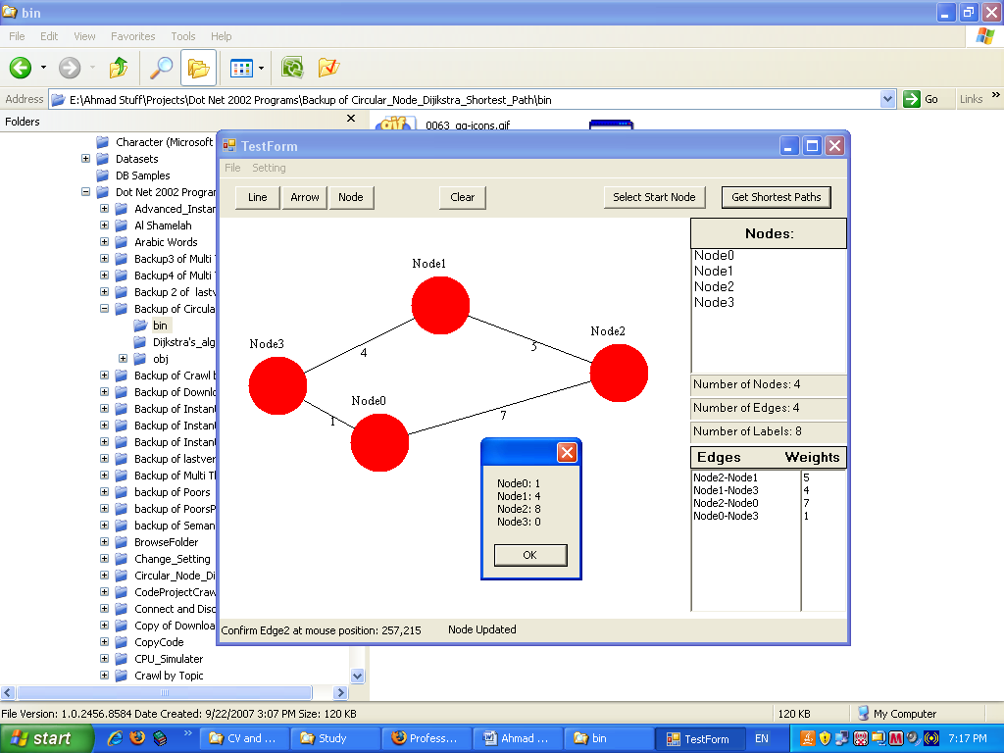
Figure 1: shortest path from Node3 to each node in the graph. “Node0” in the message box means: the shortest path between “Node0” and “Node3” is a path weighted 1.

.

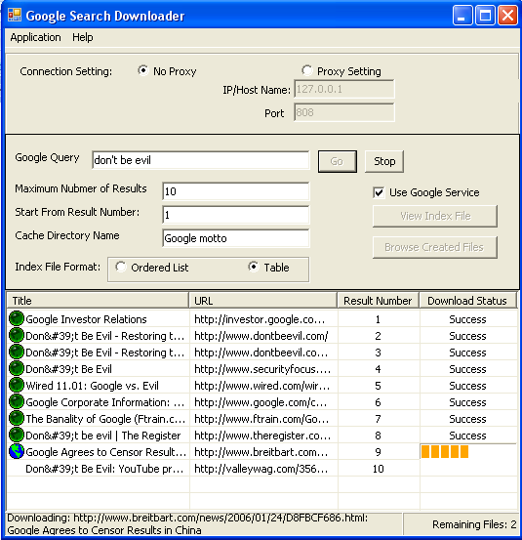
Figure 2: Google Search Downloader (Google Search API)

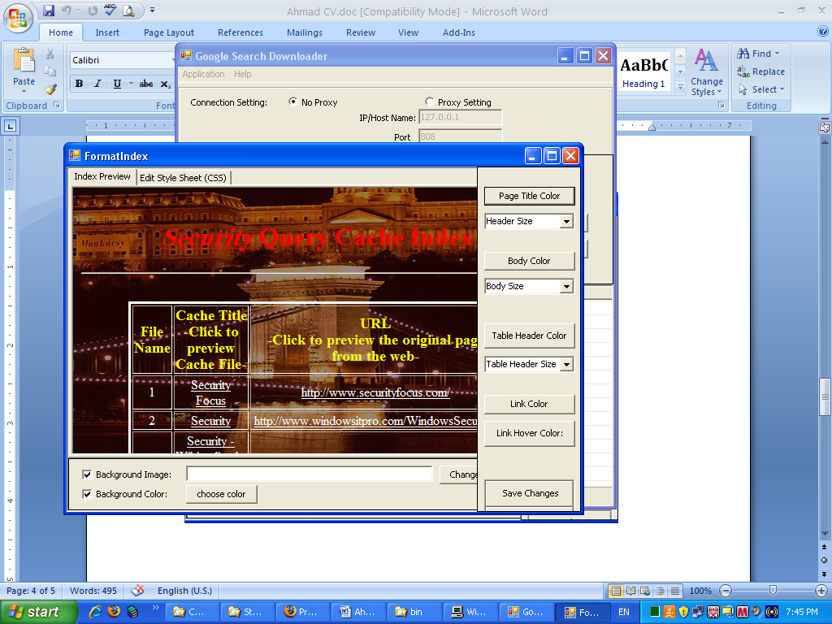
Figure 3: formatting the index file using a GUI interface.

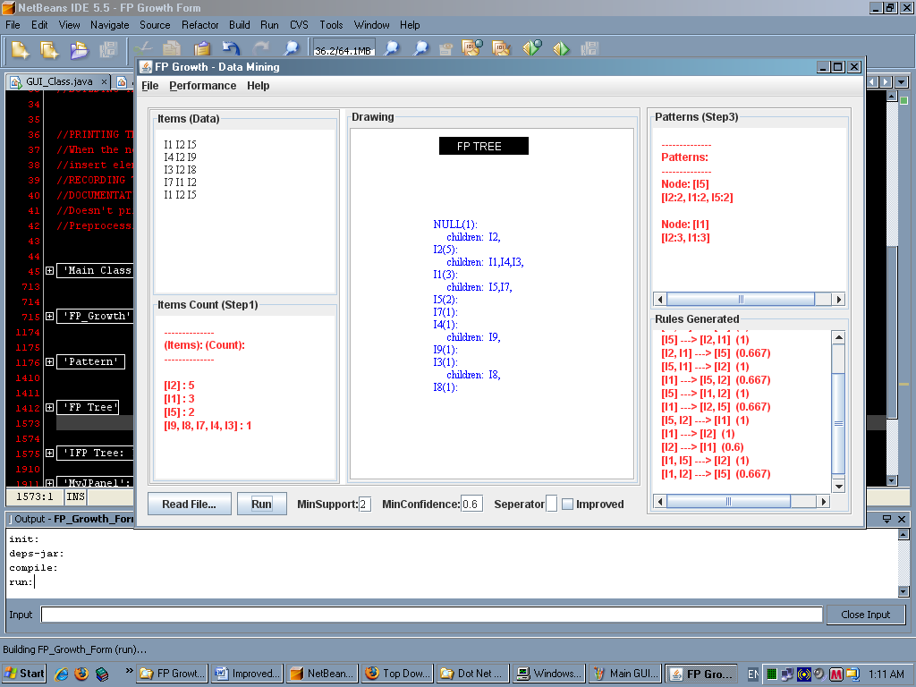
Figure 4: FP-Growth software.

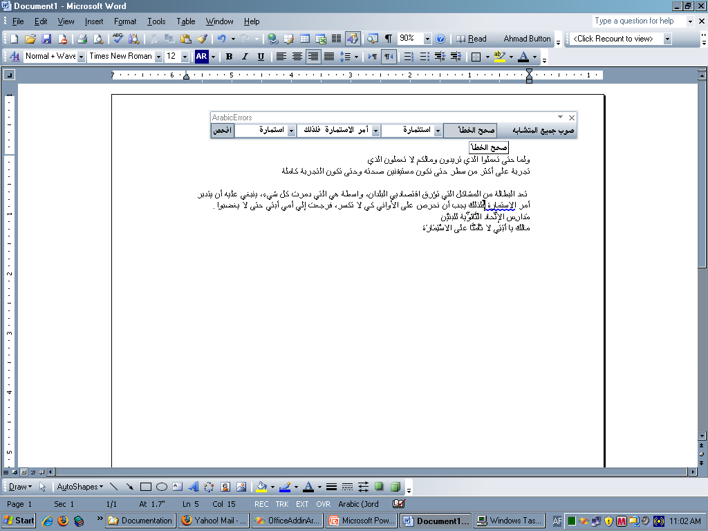

andervices Cincinnati), ems”Figure 5: Word Office Add-in to correct errors in Arabic text.

References:
- Professor Anca Ralescu, CS department at the University of Cincinnati. anca.ralescu@uc.edu
- Professor Berman, CS department at the University of Cincinnati. bermanka@ucmail.uc.edu
- Professor Han , CS department at the University of Cincinnati
han@ucmail.uc.edu
- Professor Dan Ralescu, Math department at the University of Cincinnati. dan.ralescu@uc.edu
- Doctor Rehab Duwairi, active dean of the Faculty of Computer and Information Technology. rehab@just.edu.jo
- Doctor Eyas El Qawasmeh, CS department at JUST university: eyasa@usa.net

